Docker installation

Verifiying whether it has been installed

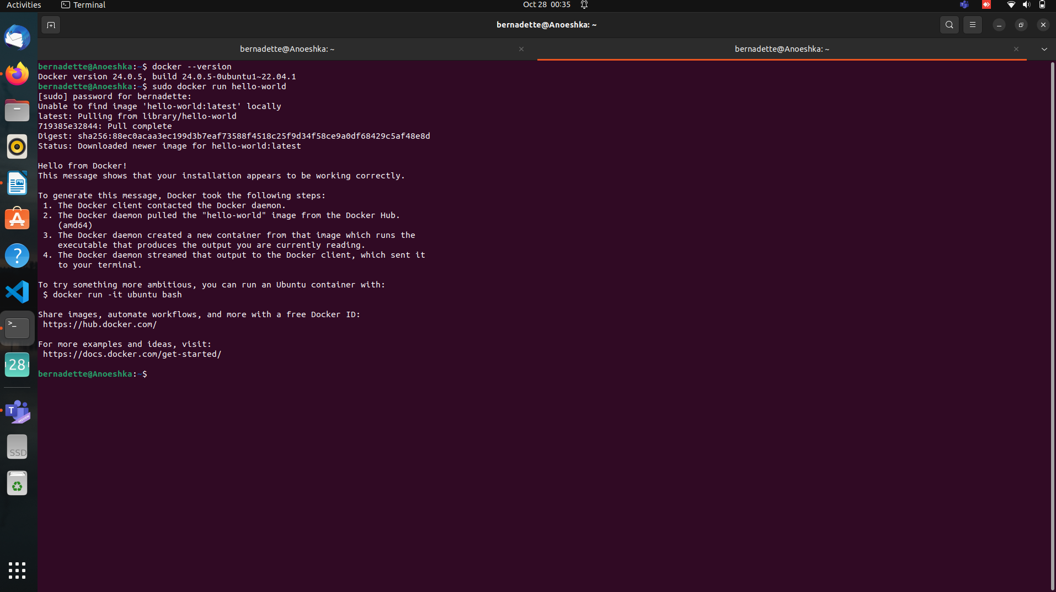

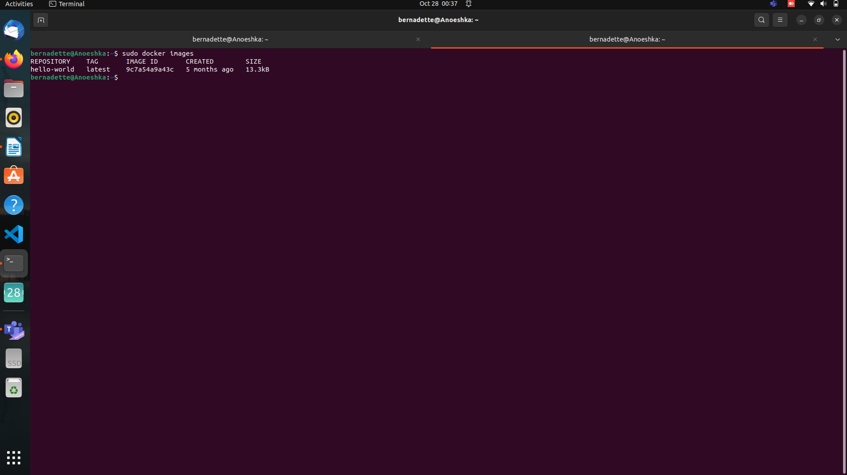
c,

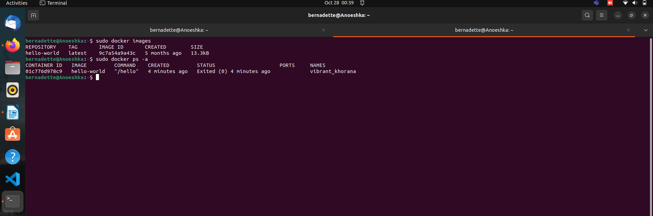
“ps -a”...for all docker images

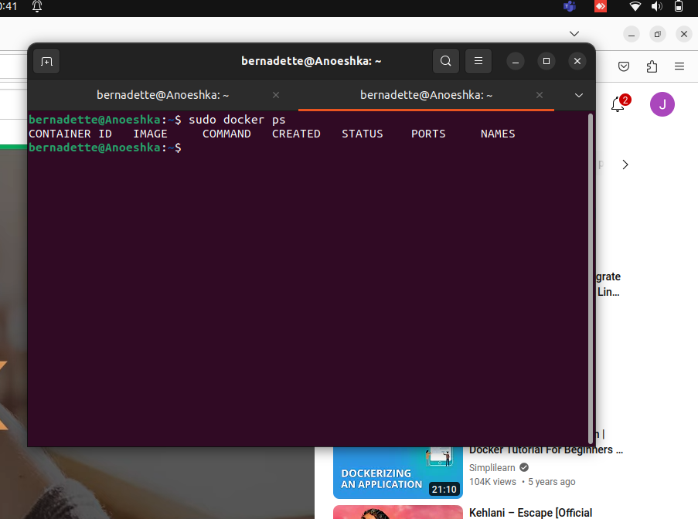
“sudo ps” for one specific docker

